Thomas Crow
Professor Martin Barron
Machine Learning
10 November 2025
K-Means Clustering in Futures Analysis
In finance, accurately predicting the return on assets is extremely valuable. Investors have been using machine learning to better understand markets for years now, and it is always interesting to see how markets behave in conjunction. Markets rarely move independently, and commodities, equity indices, currencies, and interest-rate products often respond to common macroeconomic drivers. Studying how these assets move relative to each other can provide unique insight into market structure, risk, and pricing dynamics.
Professionals in finance routinely confront problems like this, often employing advanced predictive algorithms to solve them. In “Predicting Commodity Returns Through Image-Based Price Patterns,” Hao, Liu, Miao, and Tse demonstrate that image-based predictions enhance the predictive accuracy of convolutional neural networks (CNNs). In “Option Return Predictability with Machine Learning and Big Data,” Bali, Beckmeyer, Mörke, and Weigert find that allowing for nonlinearities increases the performance of option and stock characteristics in predicting future option returns. Although these studies utilize complex techniques, they show the potential of machine learning to uncover structure in markets. My objective is to apply k-means clustering to generate insights and evaluate whether unsupervised learning can reveal meaningful patterns in the behavior of futures.
Ten one-month futures from yfinance from August 2010 – January 2025 were chosen: U.S. dollar index, natural gas, crude oil, gold, silver, copper, corn, soybeans, the S&P 500 index, and the Nasdaq 100 index. We focused on the daily closing prices of these assets and converted these prices to a percentage change in price from the previous day to normalize our data. We also calculated simple moving averages from three, seven, ten, fourteen, and thirty-day windows and thirty, ninety, and one-hundred-day standard deviations of prices for all ten futures. It should be noted that after preparing data for the model, much of it was excluded, including the dates before August 2012 and between September 2012 and September 2015.
The method applied is a k-means clustering unsupervised learning algorithm, with the initial number of clusters being five. K-means works by selecting initial cluster centroids and iteratively updating them to minimize the within-cluster distance between the data and their assigned centroid groups of datapoints, or “clusters,” are then analyzed for their similar characteristics. This method is hardly ever applied to time-series data because it is a descriptive method that is ineffective at prediction. However, our goal is to identify segments of the market that follow patterns (contango, backwardation, etc.), and for that purpose, it should work well.
Cluster Number | Count
0 | 776
1 | 354
2 | 189
3 | 232
4 | 97
5 | 176
After scaling our data, the algorithm assigned each day to a cluster for analysis, and the size of each cluster was presented for the five and six-cluster models:
Cluster Number | Count
0 | 196
1 | 221
2 | 776
3 | 534
4 | 534

Deciding the correct number of clusters was a core problem in this experiment, and our analysis illustrates how results vary depending on the number chosen. When applying the elbow method, the results were essentially smooth, and no actionable takeaways were presented.
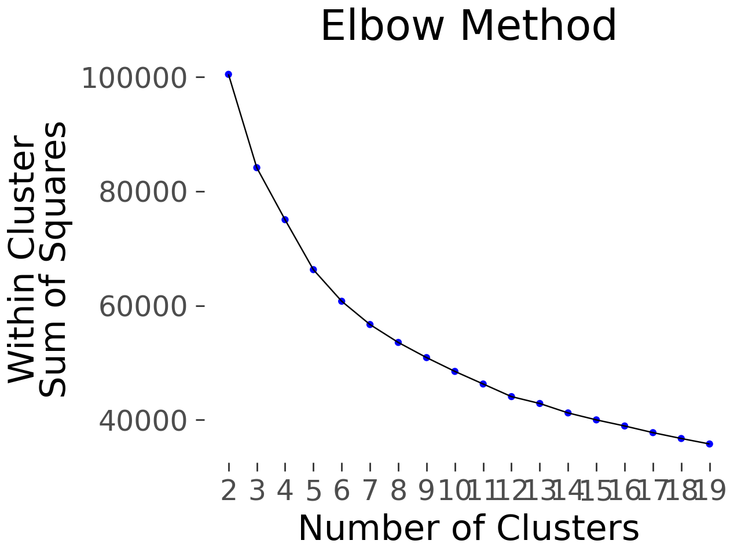
The Silhouette Method showed a best score of 0.366 for two clusters and a decrease in score for the first ten clusters, but a dramatic drop in scores for eleven to twenty clusters.
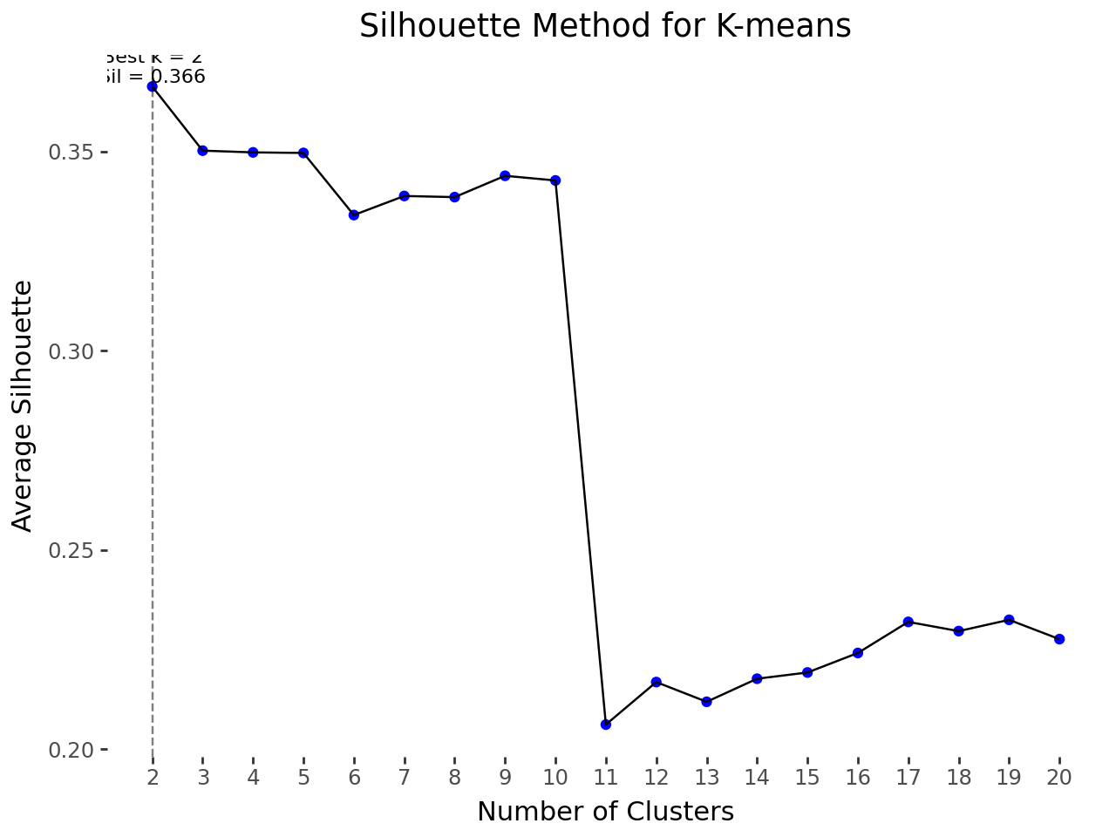
It is essential to look for localized peaks in the silhouette graph to identify where the optimal number of clusters is. However, since a localized peak would not be relevant until after eleven clusters, it is important to question whether dividing our data into that many groups would improve our analysis. It is difficult to imagine that we could identify eleven or more unique groups of market sentiment over the past decade or so, and for this reason, our cluster number will stay in single digits. This analysis best represents how cluster size should not be based on numbers generated by algorithms and shown on charts, but rather by identifying the best way to present your findings in interesting and intuitive ways to your audience.
With five clusters, the heat maps generated illustrated five distinct markets that accurately illustrated market sentiments over the periods pulled. Cluster Zero, characterized by strong contango (prices increase in the future) markets and a strengthening dollar, was plotted between 2020 and 2022, which was a period of recovery for the world economy after the COVID-19 pandemic subsided. Cluster One, characterized by markets in backwardation (future prices lower than current prices) and a weakening dollar, was plotted from 2022 to 2023, a period of heavy inflation and economic uncertainty under the Biden Administration. Clusters Two and Three were periods of mild backwardation and contango markets, respectively, but were not continuous like the first two. Cluster Four had no defined trend. Equity indices were bullish, but the other assets reflected mixed sentiments along with a weakening dollar. It was plotted over a small period after 2024, possibly representing the wild shifts our markets have experienced under the current administration. As shown by our values key on the right, no asset experienced a period where depreciation was much greater than 5%, while appreciation reached greater than 15% in some cases, including the equity indices in Zero and natural gas in Four.
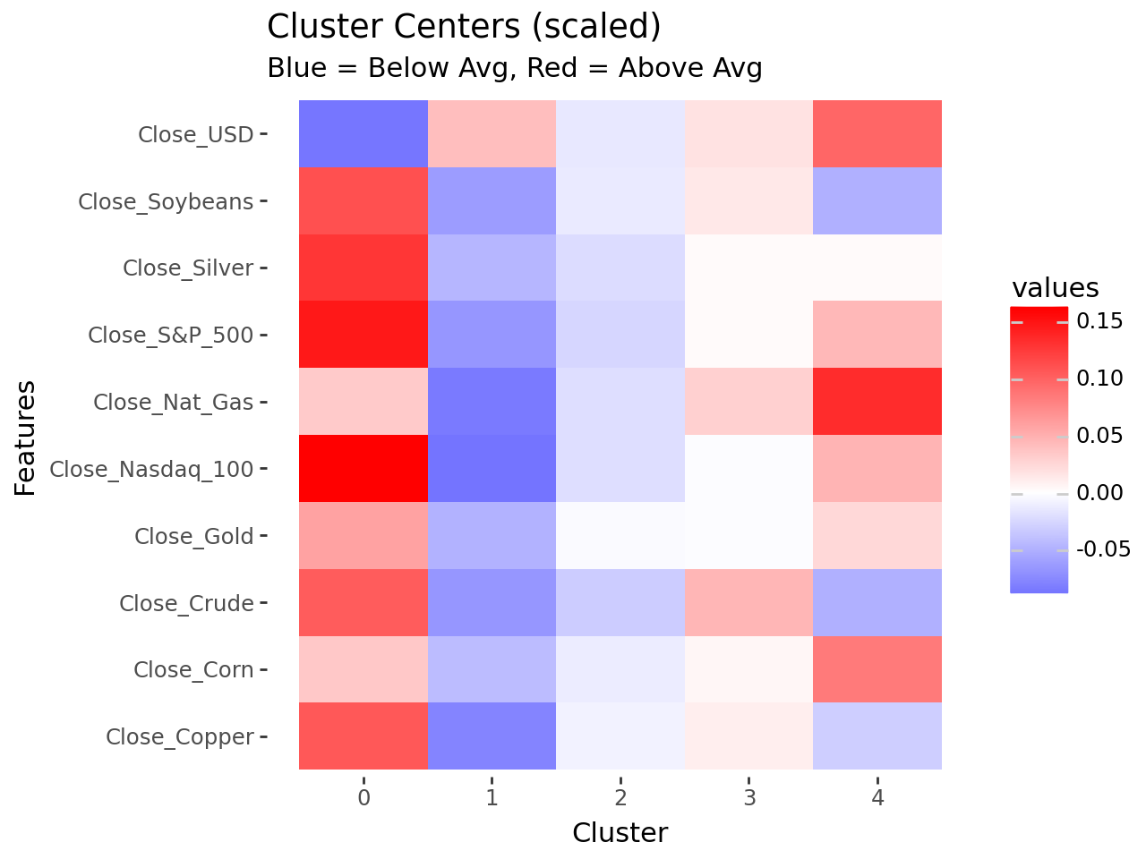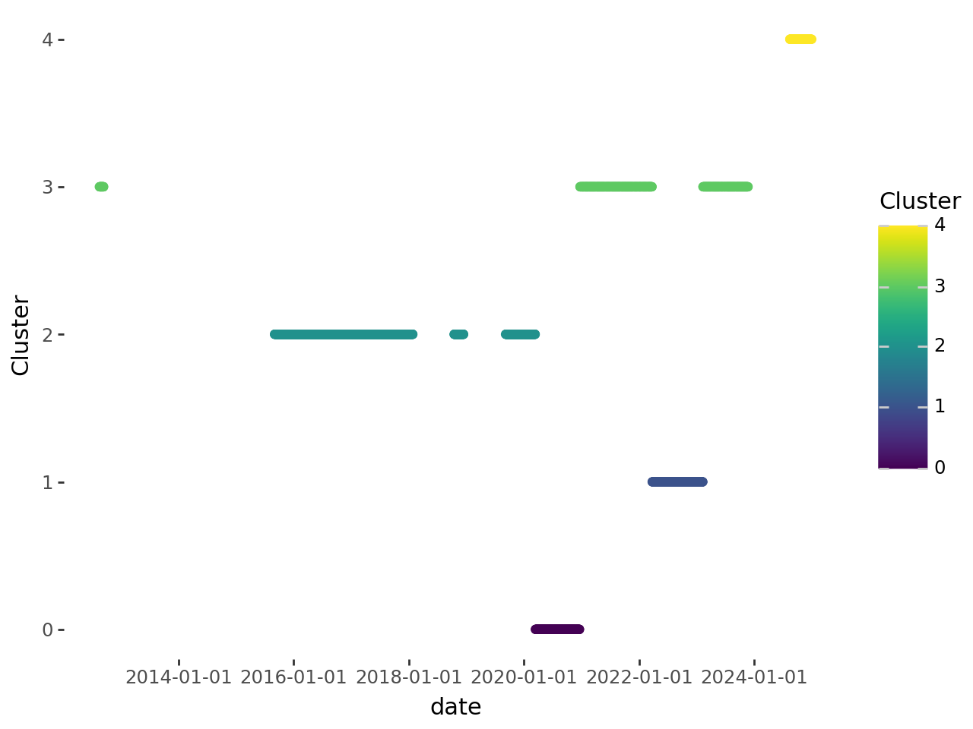
One additional cluster was added to our algorithm to assess how results might differ, and while they were numbered differently, the algorithm identified many of the same patterns. There were strong contango markets across the board after COVID, backwardation and dollar depreciation from 2022-2023, and then slightly more mixed results in the other clusters. This experiment hardly improved our analysis, and it was clear that continuing to add clusters would not help us identify trends or simplify our results.
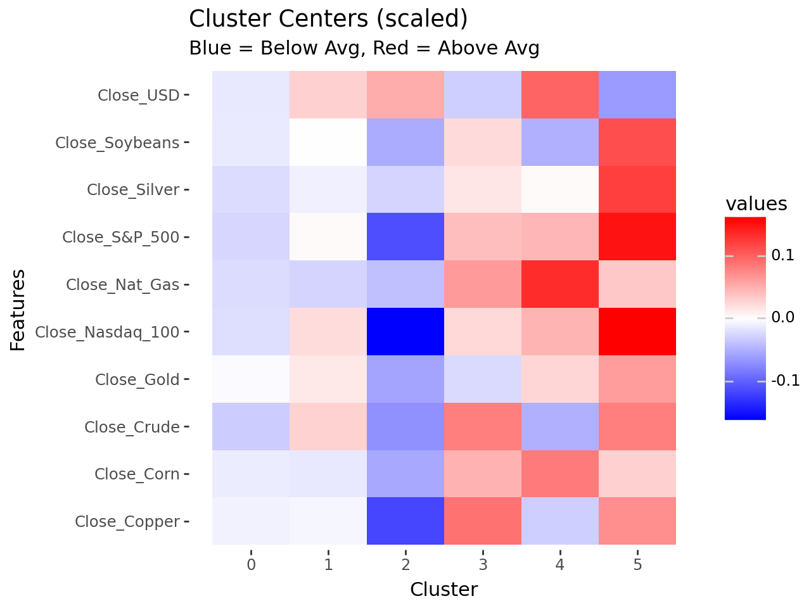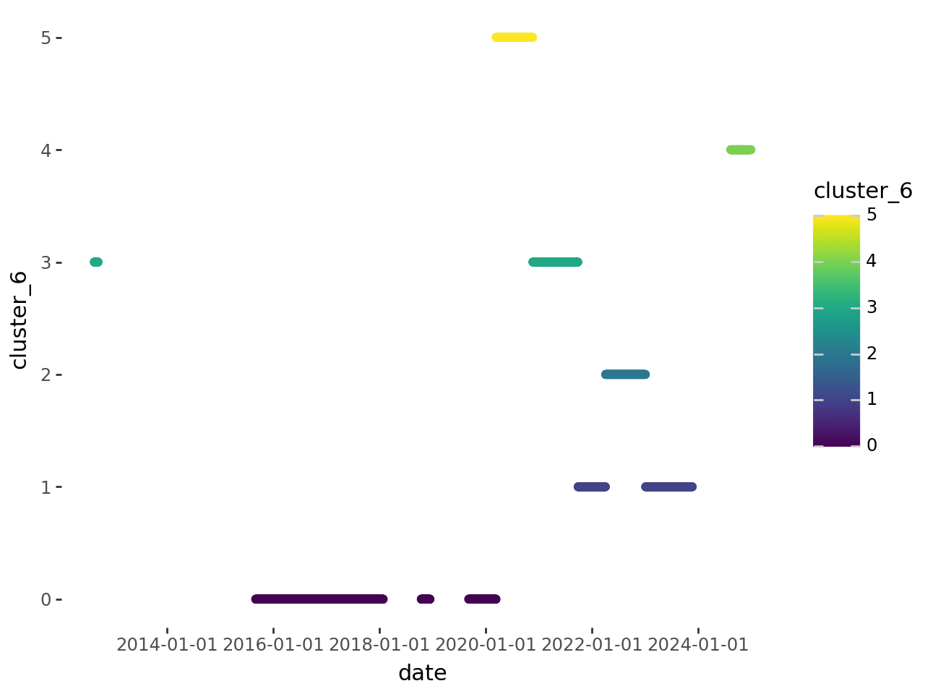

While our results were limited, this experiment was able to effectively group assets in periods of different market sentiment and create intuitive ways to see how different futures markets have moved in conjunction with each other. This algorithm is rarely applied to time-series data sets, but it performed admirably when clustering this data, and with more data could be used in fascinating experiments. In the future, it would be interesting to see how this can be applied solely to equity markets, focusing on groups of stocks (tech, financial, industrial, pharmaceutical) and seeing how these markets have moved in relation over time. In conclusion, this was an incredible introduction to running unsupervised machine learning algorithms for data analysis, and I am excited to continue experimenting with similar tools in the future.

Works Cited
Hao, T., Q. Liu, D. Miao, and Y. Tse. 2025. “Predicting Commodity Returns Through Image-
Based Price Patterns.” The Journal of Futures Markets 45: 2434–
2456. https://doi.org/10.1002/fut.70043.
Bali, T. G., Beckmeyer, H., Mörke, M., & Weigert, F. (2023). Option return predictability with
machine learning and big data. The Review of Financial Studies, 36(9), 3548–3602.
Https://doi.org/10.1093/rfs/hhad017

